JENKINS
Jenkins called as continuous integration deployment or delivery tool ( CI tool )
GIT or SVN etc
Users
U 1
U 2
U 3
Jenkins

1. UR

1. URL – GIT
2. Command : MVN
3. Time Stamp

Jenkins Installation :

→ Jenkins written in Java so JDK installation is required to execute it.

Jenkins installing in many ways

Approach 1:
1. Download and Install JDK
2. Download and install tomcat
3.Download Jenkins.war
4. Copy jenkins.war to $TOMCAT_HOME/webapps ( Deploying Jenkins to Tomcat )
5. Start Tomcat Server ( $TOMCAT_HOME(Tomcat Server Installation Location)/bin/./startup.sh ) ( To shutdown the tomcat $TOMCAT_HOME/bin/./shutdown.sh )
6. Launch Jenkins Using below URL :
http://localhost:8080/jenkins

Approach 2:

Running Jenkins directly from command line , Not suitable for production jenkins
jenkins.war comes with a light weight server called “ jetty “
Below command runs jenkins in jetty server
$java -jar jenkins.war
Launch Jenkins using below command
http://localhost:8080
Approach 3:
sudo apt-get install jenkins
Jenkins access link is :

http://localhost:8080/jenkins (or) http://IP address:8080/jenkins
If it’s existed it will show like this
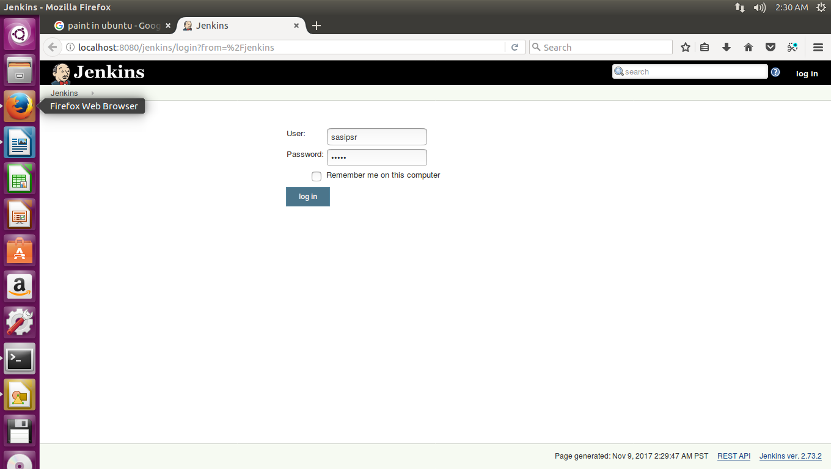

( Note: To start Jenkins tomcat should be running or in active state only( To check tomcat is running or not :
ps -ef | grep java ) If Tomcat server is in inactive mode need to active this using below command :
Go to tomcat installation foleder /bin and type ./startup.sh )

Create a Sample project :

After login click on “ create new jobs “ --→> Enter An Item Name ( Project Name ) -→> Free Style Project →> Ok

Next click on Jenkins ( Top left corner )

Next Click on Manage jenkins -→> Configure System: ( In this we have lot of options to do work on the project )

1. Is home directory , We can change if we want . To change it
$ USER_HOME/.bashrc and add the below environment variable
export JENKINS_HOME=/home/scripts/jenkins/.jenkins
2. Is System Message : Means we can write our own text about project update or any system message (like System will be shutdown from 3 pm to 6 pm ) in our own way. We can write it in many languages like html etc….

Ex :

IMG 1
If we want make it as more attractive or much suitable we can write it in html also.

Ex: We can write same text “ This is Sample Project “ In HTML .

<html>
<body>
<h1 style=”color:red;>This is sample project </h1>
</body>
</html>

After appy and save also it’s showing same html code as shown below
img 2
So in this case we need to change markup formatter from plain text to html safe
Go to manage jenkins-→> Configure Global Security -→> Markup Formatter -→> plainhtml/safe HTML: select safe HTML-→ Apply-→. Save

Then It will show like this :

IMG 3
3. # of executors : means if # of exexutors is 2 then while building the project if we want to run 3 or 4 jobs only 2 jobs will run first and remaining 2 are in queue . So if we want to run 20 jobs at a time we need set the value is 20

4. Lables:
5.Usage:
6.Quiet Period:
7. SCM checkout retry count: If any connection failure how many times need to be try to reconnect : For safer side it should be zero because If any network connection problem then only we notify that there is a connection problem immediately.
8. check box- Restict project Name: If we want a project name with a particulars then we can set this.
Ex: If we want every project name ends with .my project then we mentioned here “ .my project “
manage jenkins -→> configuration -→> Restict project naming →> pattern → > enter text in name patterns

Image 4

9. Global Properties :
10.Usage statistics :
11. Time Stamper :
12.Administrative monitors configurations :
13.Jenkins Location : By default Jenkins location is http://localhost:8080/jenkins
System Admin email address :
14. Git Hub :
a) GIT Hub server details:
15. GIT Hub enterprise servers:
16. Pipe line model defination:
a) Docker Label
b) docker registery URL
c) Registry credentials
17. Global pipe line Libraries:
18.Build-timeout Plugin > BuildStep Action
a) Check box-Enable BuildStep Action
19.
Git plugin
a) | Global Config user.name Value :
b) | Global Config user.email Value
c) | Create new accounts based on author/committer's email – Check Box –

20.
Subversion
a) | Subversion Workspace Version
b) | Exclusion revprop name

21.
Shell
a) | Shell executable

22.
Extended E-mail Notification
a) | SMTP server
b) | Default user E-mail suffix

23.
Extended E-mail Notificati
SMTP server
Default user E-mail suffix

24. Default Content Type
25. Check box – Use List Id Email header
26. Check Box – Add 'Precedence: bulk' Email Header
27. Default Recipients
28.Reply To List
29.Emergency reroute
30.Excluded Recipients
31.Default Subject
32.Maximum Attachment Size :
33.Default Content:
34.Default Pre send script:
35.Default Post-send Script
36.Additional groovy classpath
37.Check Box –-Enable Debug Mode
38. Check Box –-Require Administrator for Template Testing
39. Check Box –-Enable watching for jobs
40.Check Box – Allow sending to unregistered users
41. Content Token Reference
42.Email Notification :
a) SMTP server:
b) Default user e-mail suffix
43.Check Box – Test configuration by sending test e-mail
ENABLE SECURITY SETTINGS IN JENKINS:

Manage Jenkins -→> Configure Global Security -→>

1. Enable Security : Should be enable for To enable security settings
2. Access Control :
Here we concentrate mainly on two options
A) Jenkins Own User Data base : It allows
B) LDAP :

LDAP means In a organization different portals or there like jenkin. HR, remedy, CSS etc..
For each and every portal we need to create a user name and password to do access , So it’s very difficult to create it for all portals and delete also . To overcome this we create the credentials in LDAP server and point it to all portals like shown in below :
3. Authorization : In this Matrix-based security is important .
Marix-based Security : In this “ Anonymous Users “ need to be Administrative
and we can create different users and give particular credentials like shown below.
( Here we created a new user sasipsr )
Image 5

4. Mark Up Formatter : It means A project heading or note mentioned in which format means in plain text or HTML format .

5.CSRF Prtotection :

6.CLI:

7. Plugin Manager :

8.Hidden Security Manager :

9.SSH server :

RELOAD CONFIGURATION FROM DISK :( Modify anything from backend )

Suppose we modified a file from CLI it’s not reflecting in Jenkins web app, For this we need to click it on Reload Configuration From Disk
Ex: Suppose we modified in pom.xml as JDK version changed from JDK 7 to JDK 8
In this case we need to reflect in Jenkins We have to click on Reload Conf From Disk.

System Information:

It will show all system information like home directory etc…

Image 5

System Logs :

It will show all system logs like Jenkins logs and jenkins errors and configurtion history and records of each and every job change or modification ( In CLI we can see the jenkins error logs in Jnekinslogs/jenkinserrors

